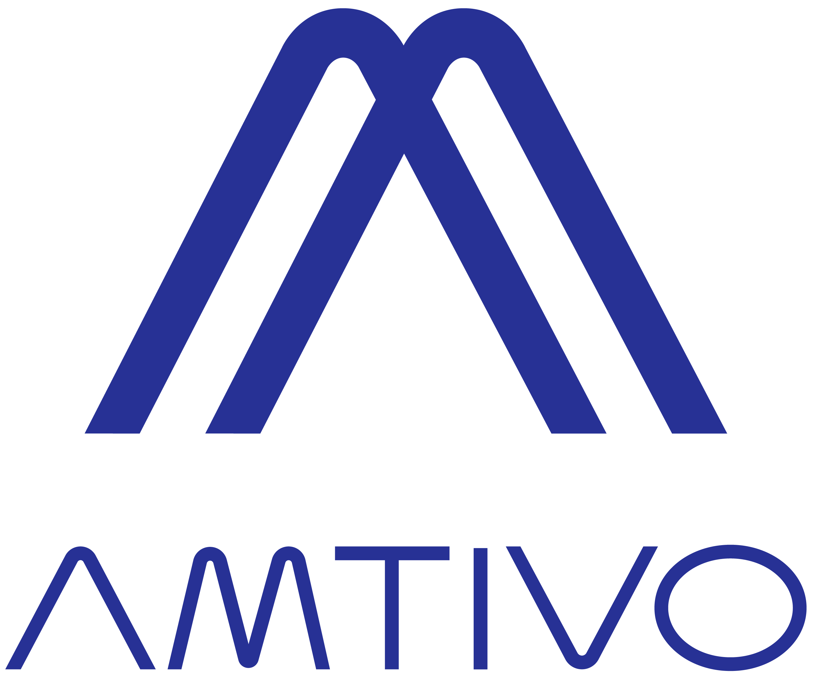
CERTIFICATE OF REGISTRATION
The management system of certiﬁcate number 264005
Axiom Engineering, Inc.
901 S. West Street, Wichita, KS, 67213, USA
has been audited in accordance with the requirements of AS 9104/1 dated 2012-01
AS 9100 D / ISO 9001: 2015
Precision Machining and Minor Assembly of Aerospace Parts
Further clariﬁcations regarding the scope of this certiﬁcate and the applicability of requirements may be obtained by consulting the certiﬁer.

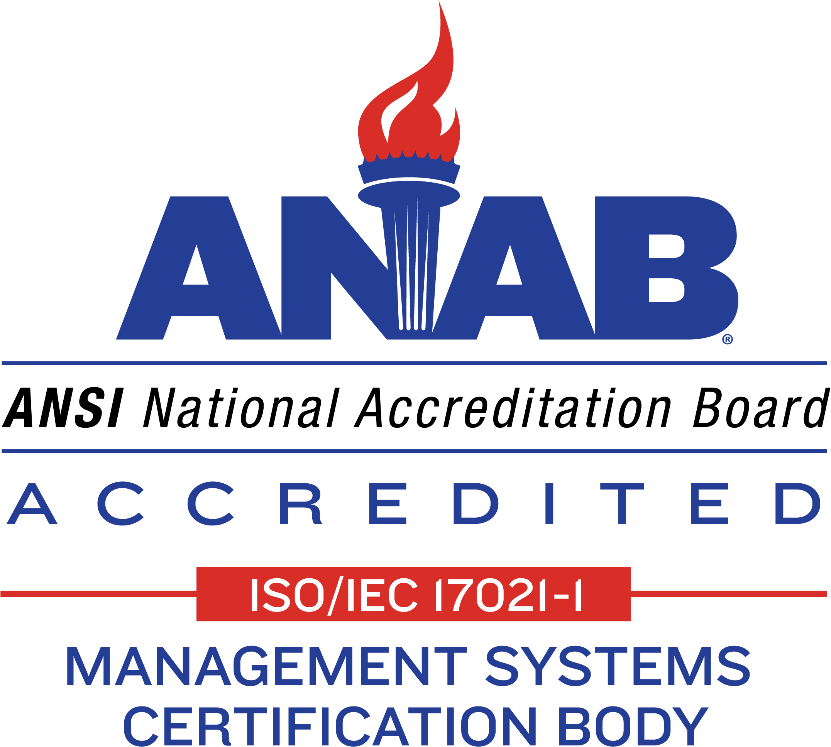
Initial certiﬁcation: Tuesday, March 20, 2007 Current cycle start: Tuesday, March 18, 2025 Latest issue: Wednesday, January 22, 2025
Expiry date: Friday, March 17, 2028
Subject to annual assessments.
Certiﬁcation structure: Single Site
Authorized by

Mike Tims
Chief Executive Ofﬁcer

amtivo.us
Certiﬁcate issued by Amtivo (USA) Inc.
Amtivo (USA) Inc. is accredited under the (ICOP) Industry Controlled Other Party (Americas) scheme
Certiﬁcation is conditional on maintaining the required performance standards throughout the certiﬁed period of registration.
Amtivo (USA) Inc, 7502 W. 80th Avenue, STE. 225 Arvada, Colorado 80003-2128, USA.

